Agenda Item: 2/01

= application site



Roger Bannister Sports Centre | P/1776/20

Location Plan

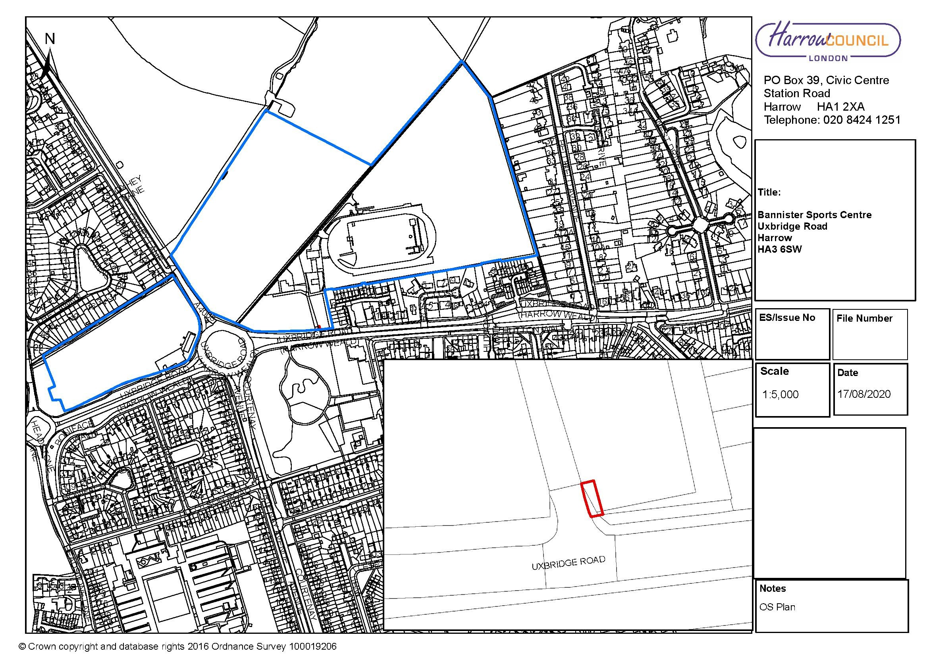

LONDON BOROUGH OF HARROW

PLANNING COMMITTEE

2nd September 2020

APPLICATION NUMBER: | P/1776/20
VALIDATE DATE: | 8TH JUNE 2020
LOCATION: | ROGER BANNISTER SPORTS CENTRE, UXBRIDGE ROAD
WARD: | HARROW WEALD
POSTCODE: | HA3 6SP
APPLICANT: | HARROW COUNCIL
AGENT: | N/A
CASE OFFICER: | NABEEL KASMANI
EXTENDED EXPIRY DATE: | 8TH SEPTEMBER 2020

PROPOSAL

Enlargement of vehicle access (retrospective)

RECOMMENDATION

The Planning Committee is asked to:

- agree the reasons for approval as set out in this report, and

- grant planning permission subject to the conditions listed in Appendix 1 of this report:

REASON FOR THE RECOMMENDATIONS

The enlarged vehicle crossover facilitates the safe movement of heavy goods vehicles into the site to allow development associated with implemented planning permission reference P/4748/18 for the upgrading and regrading of existing sports pitches to progress. The enlarged vehicle crossover is not inappropriate development within the Green Belt and has an acceptable impact with regard to character and appearance of the locality, amenity of neighbouring occupiers, highways and drainage.

Accordingly, weighing up the development plan policies and proposals, and other material considerations including comments received in response to notification and consultation as set out below, officers conclude that the proposed development is worthy of support.

PROCEDURAL ISSUES

The application is also made under Regulation 3 of the Town and Country Planning
Regulations 1992 (as amended). Regulation 3 permits a local authority to make an
application to itself for planning permission to develop land within its area and to then
also determine the application

INFORMATION

This application is reported to Planning Committee at the request of a nominated member in the public interest. The application is therefore referred to the Planning Committee as it does not fall within any of the provisions set out at paragraphs 1(a)-1(h) of the Scheme of Delegation dated 12th December 2018.

Statutory Return Type: | (E)18
Council Interest:  Net Additional Floorspace: | n/a  n/a
GLA Community Infrastructure Levy (CIL): | n/a
Local CIL requirement: | n/a

HUMAN RIGHTS ACT

The provisions of the Human Rights Act 1998 have been taken into account in the processing of the application and the preparation of this report.

EQUALITIES

In determining this application the Council has regard to its equalities obligations including its obligations under section 149 of the Equality Act 2010.

For the purposes of this application there are no adverse equalities issues.

S17 Crime & Disorder Act

Policies 7.3.B and 7.13.B of The London Plan and Policy DM1 of the Development Management Polices Local Plan require all new developments to have regard to safety and the measures to reduce crime in the design of development proposal. It is considered that the proposed access does not adversely affect crime risk.

- SITE DESCRIPTION

1.1 The application site relates to the vehicular access serving the Roger Bannister Sports Centre located on the northern side of Uxbridge Road, near the roundabout junction with Oxhey Lane and Courtney Avenue.

1.2 The car park serving the Sports Centre is located immediately to the east of the vehicular access road. To the west of the access road is a grass field which has been granted planning permission to provide an 18 Hole Golf Adventure experience with facility to include themed props and ancillary kiosk.

- PROPOSAL

2.1 The retrospective application relates to the enlargement of the vehicle access which increases the width of the access bell mouth curb line by 2 metres and extended 6 metres further north.

- RELEVANT PLANNING HISTORY

Ref no. | Description | Status & date of decision
P/4748/18: | Upgrading and regrading of existing sports pitches to create four natural grass pitches and one 3G synthetic pitch with floodlights, Maintenance Equipment Store & Two Team Dugouts; associated landscaping and security fencing (4.5m high ball stop fence and 1.2m-2m high pitch perimeter barrier) | Granted: 02/08/2019
P/3633/19 | Details pursuant to conditions 9 (construction method plan) 11 (piped watercourse) 12 (arboriculture) 13 (arboriculture - pruning) | Approved:  06/12/2019
P/3959/19 | Creation of 49 additional car parking spaces (inclusive of 2 disabled spaces); replacement of path | Under Consideration
P/0561/20 | Variation of condition 21 (revised car parking provision) attached to planning permission P/4748/18 dated 2/8/19 to allow the 3G artificial grass pitch to be used from the beginning of September 2020 | Grant  27/07/2020

- CONSULTATION

4.1 A total of 11 consultation letters were sent to neighbouring properties regarding this application. The minimum statutory consultation period expired on 6th July 2020

4.2 No comments have been submitted following the public consultation.

4.3 Statutory and Non Statutory Consultation

4.4 The following consultations have been undertaken and a summary of the consultation responses received are set out below.

Consultee and Summary of Comments

LBH Highways
No Objection. The proposal would enable access by HGV’s into the site to enable construction to take place

LBH Vehicles Crossings Officer
No Objection

5.0 POLICIES

5.1 Section 38(6) of the Planning and Compulsory Purchase Act 2004 requires that:

‘If regard is to be had to the Development Plan for the purpose of any determination to be made under the Planning Acts, the determination must be made in accordance with the Plan unless material considerations indicate otherwise.’

5.2 The Government has issued the National Planning Policy Framework [NPPF 2019] sets out the Government’s planning policies for England and how these should be applied, and is a material consideration in the determination of this application.

5.3 In this instance, the Development Plan comprises The London Plan 2016 [LP] and the Local Development Framework [LDF]. The LDF comprises The Harrow Core Strategy 2012 [CS], Harrow and Wealdstone Area Action Plan 2013 [AAP], the Development Management Policies Local Plan 2013 [DMP], the Site Allocations Local Plan [SALP] 2013 and Harrow Local Area Map 2013 [LAP].

5.4 While this application has been principally considered against the adopted London Plan (2016) policies, some regard has also been given to relevant policies in the Draft London Plan (2019), as this will eventually replace the current London Plan (2016) when adopted and forms part of the development plan for the Borough.

5.5 The document was originally published in draft form in December 2017 and subject to Examination in Public (EiP) with the Panel’s report published in October 2019. The Mayor of London has considered these recommendations, and has either accepted them or where not, provided justification as to why accepting them would not be appropriate. The Mayor has now submitted to the Secretary of State an ‘Intend to Publish’ version of The Plan. It is for the Secretary of State to determine whether he agrees with the revised Plan and it ought to be published in that form.

5.6 The Draft London Plan is a material planning consideration that holds significant weight in determining planning applications, with relevant polices referenced within the report below and a summary within Informative 1.

6.0 ASSESSMENT

6.1 The main issues are;

Principle of the Development
Character and Appearance
Residential Amenity
Transport and Parking
Flood Risk and Drainage

6.2 Principle of Development

6.2.1 The relevant policies are:
- National Planning Policy Framework (2019)
- The London Plan (2016): 7.16
- The Draft London Plan (2019): G2
- Harrow Core Strategy (2012): CS1
- Harrow Development Management Policies (2013): DM16

6.2.2 The application site is within the Green Belt. The proposal provides approximately 15m² of additional width to the vehicular access way from the already hard-surfaced pavement and car park which would serve to provide access for the construction of outdoor sport and recreation facilities that have been previously granted planning permission. On this basis, it is considered that the proposal does not constitute inappropriate development within the Green Belt and does not conflict with the purposes of land within it. On this basis, the proposal complies with the relevant policies in this regard.

6.3 Character, Appearance and Heritage

6.3.1 The relevant policies are:
- National Planning Policy Framework (2019)
- The London Plan (2016): 7.4, 7.6,
- The Draft London Plan (2019): D1
- Harrow Core Strategy (2012): CS1,
- Harrow Development Management Policies (2013): DM1

6.3.2 The increased width of the vehicular entrance does not have a detrimental impact on the character or appearance of the locality. The proposal is therefore considered to comply with the relevant policies in this regard.

6.4 Residential Amenity

6.4.1 The relevant policies are:
- National Planning Policy Framework (2019)
- The London Plan (2016): 7.6,
- The Draft London Plan (2019): D2,
- Harrow Core Strategy (2012): CS1
- Harrow Development Management Policies (2013): DM1

6.4.2 The increased width of the vehicular access does allow heavy goods vehicles to enter the site for construction purposes. Given that the vehicular access is sited approximately 22 meters away from the rear gardens of the adjacent residential properties within Birch Park, and the likely use by heavy use goods vehicles would only be temporary, during the construction period, officers consider that the proposal does not have a detrimental impact on the residential amenities of the adjoining occupiers. For these reasons, the proposal complies with the relevant requirements of the policies with regard to residential amenity.

6.5 Traffic and Parking

6.5.1 The relevant policies are:
- National Planning Policy Framework (2019)
- The London Plan (2016): 5.3
- The Draft London Plan (2019): T7
- Harrow Core Strategy (2012): CS1
- Harrow Development Management Policies (2013): DM1, DM43

6.5.2 The Council’s Highways officer and Road Network Management Officer have raised no objections to the proposal. On this basis, it is considered that the proposal does not have a negative impact on the functioning or safety of the highway. The application therefore complies with the relevant policies in this regard.

6.6 Flood Risk and Drainage

6.6.1 The relevant policies are:
- National Planning Policy Framework (2019)
- The London Plan (2016): 5.13
- The Draft London Plan (2019): SI13
- Harrow Core Strategy (2012): CS1
- Harrow Development Management Policies (2013): DM10

6.6.2 The proposal replaces the hardstanding for the existing car-park with that for the enlarged vehicle access. There is therefore no net increase in impermeable surfaces. On this basis, it is considered that the proposal has a neutral impact with regard to drainage. The proposal therefore complies with the relevant policies in this regard.

7.0 CONCLUSION AND REASONS FOR APPROVAL

6.1 The enlarged vehicle crossover facilitates the safe movement of heavy goods vehicles into the site to allow development associated with implemented planning permission reference P/4748/18 for the upgrading and regrading of existing sports pitches to progress. The enlarged vehicle crossover is not inappropriate development within the Green Belt and has an acceptable impact with regard to character and appearance of the locality, amenity of neighbouring occupiers, highways and drainage.

6.2 For all the reasons considered above, and weighing up the development plan policies and proposals, and other material considerations including comments received in response to notification and consultation as set out above, this application is recommended for grant.

APPENDIX 1: Conditions and Informatives

Conditions

- Approved Plans and documents

The development hereby permitted shall be retained in accordance with the following approved plans:

T/DWG/001422, OS Plan

Reason: For the avoidance of doubt and in the interests of proper planning.

Informatives

- Planning Policies

The following policies are relevant to this decision:
National Planning Policy Framework (2019) (NPPF)
London Plan (2016): 5.3, 5.13, 7.4, 7.6, 7.16
Draft London Plan (2019): H1, D1, D2, G2, T7, SI13,
Harrow Core Strategy (2012): CS1,
Development Management Policies (2013): DM1, DM10, DM16, DM43

CHECKED

Interim Chief Planning Officer | Orla Murphy pp Beverley Kuchar | 20.8.20
Corporate Director | Hugh Peart pp  Paul Walker | 20.8.20

APPENDIX 2: SITE PLAN

APPENDIX 3: SITE PHOTOGRAPHS

Bannister Main Entrance
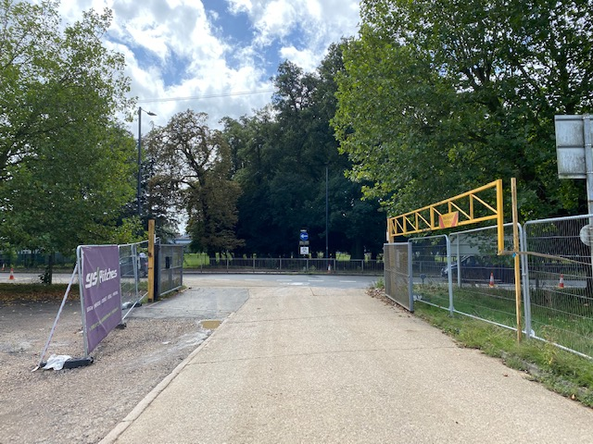

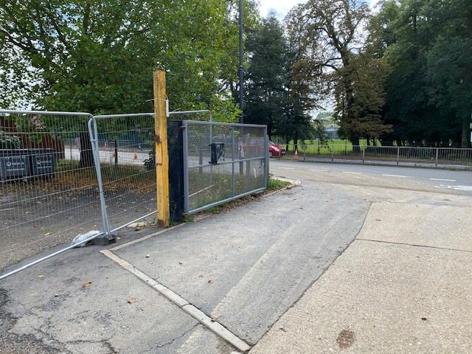

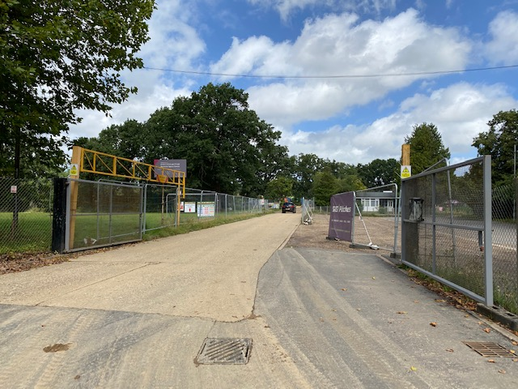

APPENDIX 4: PLANS AND ELEVATIONS



